ME 50361: Individual Assignment

Babcock Group Sustainability Report

Sadiq Tijjani Umar

University Of Bath

Word Count: 2,052

Table of Contents

Introduction 2

Strategy Review 2

Recommendation 3

Short Term 4

Medium To Long Term 4

References 5

# Introduction

The global climate crisis has the potential to be catastrophic on multiple levels, it threatens to undermine the entire sustenance system for earth’s biotic life, including drinking water, clean air, food supply and shelter. The World Health Organization(WHO) estimates that, between 2030 and 2050, “climate change is expected to cause approximately 250 000 additional deaths per year from malnutrition, malaria, diarrhea and heat stress alone. The direct damage costs to health are estimated to be between US$ 2–4 billion per year by 2030. Areas with weak health infrastructure – mostly in developing countries – will be the least able to cope without assistance to prepare and respond”(WHO,2022). In 2015, a symposium was formed of 196 different countries whose goal was to set a limit on global warming to well below 2 degrees Celsius in comparison to pre-industrial levels(United Nations, 2015). This symposium led to an agreement known as The Paris Agreement, a legally binding international treaty on climate change adopted at the United Nations COP 21 meeting in Paris on the 12th of December 2015 and was made operative on the 4th of November, 2016.

The Climate crisis will produce as a consequence of itself a number of crucial security issues, inter-state relationships are forecasted to become increasingly strained as different argues debate how to reduce emissions, Internal conflicts within countries(developing countries particularly) are likely to increase as vital resources become scarce, this coupled with a highly likelihood of more extreme weather patterns will increase the risk conflicts over water and mass migration of people from the worst hit countries to relatively better off countries(National Intelligence Council, 2021). With the UK seeing a new high in net migration since the second world war(Office for National Statistics, 2022) the climate crisis takes on a new dimension, one that requires the active involvement of the ministry of defense and all it’s major suppliers across the supply chain.

Babcock is a British engineering and defense services company and is one of the UK ministry of defense’s biggest suppliers and managers of mission critical defense assets and infrastructure. In recognition of the critical issues presented by the climate crisis, Babcock put into effect it’s climate strategy “Plan Zero 40”, committing itself to delivering net zero emissions from Scopes one and two by 2040 and Scope three by 2050. This report will analyze Babcock’s climate strategy, outline areas of strength, weakness and opportunity and the finally build upon the outlined opportunities to provide strategic recommendations for improving the organization’s climate strategy.

# Strategy Review

For an organization to identify all emissions set off by it’s operations, greenhouse gas (GHG) emissions are categorized into direct emissions, of which all emissions come from sources that are owned by the organization, and in-direct emissions, of which all emissions are set off due to the activities of the organization but have their source from entities owned or controlled by another company. To increase transparency and accuracy direct and indirect emissions are further delineated into three “scopes”. Scope 1 emissions are those that occur from sources owned by the organizations, scope 2 emissions are those that occur from the generation of purchased electricity(or heat) consumed by the organization and finally scope 3 emissions are those that occur from sources not owned or controlled by the company but are released as a result of activities undertaken on behalf of the organization(Greenhouse Gas Protocol, 2015).

Babcock’s “Plan Zero 40” strategy is an emission reduction initiative that commits the organization to a science based target in accordance with the 1.5 degree Celsius limit to global warming and to transitioning to Net Zero within it’s scope 1 and scope 2 emissions by 2040 and then it’s scope 3 emissions by 2050[1]. The annual report released by the Babcock group in 2021 indicates that for the year 2021 the organization emitted some 200,705 tonnes of carbon dioxide equivalent(tCO2e), 95% of which was a result of emissions from scopes 1 and 2(Babcock, 2021), decreasing from 229,103 tCO2 in 2020 and 258,328 tCO2 the previous year.

Given the importance and immediacy of meeting their 2040 Net zero emissions benchmark for scope 1 and scope 2, the Babcock group has put together a tentative sustainability strategy to be able to meet this target, these strategies present both opportunities and risks to the business, a summary of these risks and opportunities are outlined in the following table;

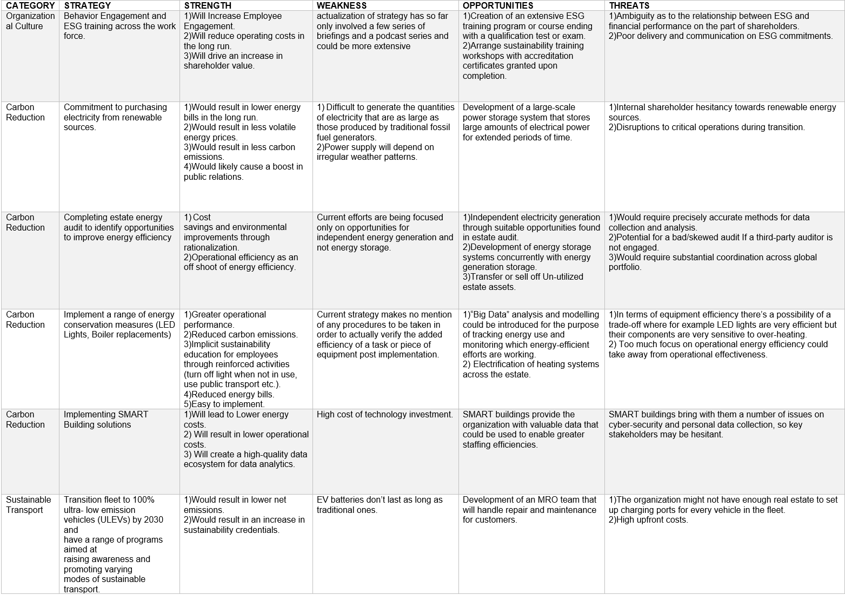

*Figure Analyzing Babcock’s Strategies for Scopes 1 and 2 using the SWOT Model*

Scope 3 related activities as reported on the annual report for the year 2021 only accounted for 8050 tCO2e of emissions, to curtail this issue the organization has committed to concurrently engage the supply chain to understand, manage and reduce it’s wider environmental impacts while also developing an environmental data management system, preparing waste management plans across all significant sites by 2024, zero controlled waste to landfill by 2025 and eliminating the use of unavoidable single-use plastic by 2027, however, a further delve into the organization’s publications found that the figure(and it’s accompanying strategies) reported in the annual report only accounted for upstream activities. Carbon reduction plans released in 2021 including both upstream and downstream activities provided an estimate of 613,464.2 tCO2e for 2021 and 675,731.2 tCO2e for 2020, making scope 3 the area in which the most carbon emissions are released within the organization(Babcock, 2021).

The carbon reduction plan also indicates that operations within scope 1 and 2 emitted a total of 213,380.4 tCO2e in 2021 and 232940.4 in 2020, figures published in the document indicate that Babcock is en-route to meeting it’s net zero emission goal for scopes 1 and 2 earlier than the targeted date of 2040[2], the same can be said for scope 3 emissions and it’s 2050 net zero target[3]. Taking into consideration dunphy’s levels of engagement(dunphy et al, 2012) and the language used in the report, Babcock’s initiative on employee health and safety through it’s electronic global safety information management system and proactive reporting together with it’s willingness to engage with other parties within and outside the defense sector on shared sustainability goals and to comply with emission reporting policies(Babcock, 2022) place it at the level of a stage 4 sustainable corporation(efficiency). However, the organization’s desire to conduct bio-diversity assessments and deliver a 10% bio-diversity increase across it’s estates together with it’s plans to identify water reduction opportunities and to incorporate water reduction technologies such as rainwater harvesting, leak detection and flow restriction(Babcock, 2022) indicate that the organization aims to be one of strategic proactivity.

All relevant data gathered from the organization’s publications indicate that they are well on their way to meeting their emission targets however data collection regarding downstream scope 3 emissions are still a big stand-out for the organization, making estimates for scope 3 emissions unstable, the strategies presented for scope 1 and scope 2 will have their weakness(as anticipated in the SWOT analysis) but the organization has indicated that they have plans to improve especially in key areas such as ESG training, however, more can be done to move the organization from a position of being reactive to pressing sustainability issues to one of strategic proactivity.

# Recommendation

This section is divided into two subsections with the short term suggestion containing an addition to the current strategy for carbon reduction in scopes one and two and the medium to long term containing suggestions that’ll cover the general sustainability plan but is oriented towards getting a handle on scope 3 emissions.

# Short Term

Incorporating carbon reduction offsets into the sustainability strategy merits the organization with credits or “rights” linked to activities that lower the amount of carbon dioxide (CO2) in the atmosphere(MIT, 2020). These credits will serve as compensation for emissions generated within the organization’s operations, however, offset schemes that the organization decides to engage with must always have a high quality verifier behind them such as Gold standard, Verra and the Voluntary Carbon Standard(VCS) in order to prevent any greenwashing that’ll make the sustainability effort look more impactful than it really is, it is important that the offset schemes come only as secondary activities to strategic processes aimed at reducing emissions within the organization’s operations. Particularly in it's operations in developing countries, Babcock can partake in initiatives using sustainable means to provide electricity and clean water to low income communities, however, the organization should eventually transition to initiatives that directly remove carbon from the atmosphere in order to maintain credibility in it’s net zero aligned offsetting(Oxford Offsetting Principles, 2020). In this regard, the organization can look into carbon capture technology as it becomes more efficient and less costly, during it’s estate audit the organization can look into opportunities to install such technologies on it’s bases, this way the organization will pay upfront costs that will lead to future cost reduction, moreover, since scope 3 emissions contain processes that are difficult to quantify and decarbonize, offsetting activities provide a way for the organization reduce emissions while researching decarbonization efforts for mission critical processes in the downstream.

# Medium To Long Term

Further investigation into the reports of other top defense contractors in the UK who have aligned to set science-based targets to meet the Paris Agreement goals for containing global warming has shown that Babcock in comparison to it’s competitors invests substantially less into research and development despite having higher net revenue, in 2020 and 2021 Meggit saw a revenue accrual of £1.6 and £1.4 billion respectively(Meggit Annual Report, 2021) with £70 million going into R&D in 2021 and £97 million in 2020 while Qinetiq had a revenue income of £1.3 and £1.2 billion in 2022 and 2021 respectively, with £302 million going into R&D in 2022. On the other hand, Babcock saw £4.1 and £3.9 billion in revenue for 2022 and 2021 respectively but only £2.6 million went into R&D in 2022 and even less so in 2021(Babcock Annual Reports, 2022). A **higher portion of net revenue should be allocated towards R&D purposes** that’d allow the organization develop machines, processes or systems that can be energy efficient and incredibly effective at the same time across it’s land, marine and aviation operations.

Particularly, the organization can look into **automation,** both of it’s manufacturing processes and of it’s manned vehicles. Incorporating the Industry 4.0 concept of a Cyber-Physical-System where sensors, machines, workpieces and IT systems are connected across the value chain beyond a single enterprise, nodes within the system will be able to communicate with one another using Internet based protocols allowing them to perform data analysis to predict failure, self-configure and make adjustments to adapt to changes, this has been shown increase productivity, efficiency and revenue growth(Rüßmann et al,2015). Though still in it’s infancy, Industry 4.0 has shown promise in enabling sustainable manufacturing through increasing flexibility, resource efficiency using big data analysis for predictive maintenance and fast production system reconfiguration, waste reduction and production of renewable energy surpluses that can be used in other operations within organization(Hermann, Pentek, and Otto [2016](https://www.tandfonline.com/doi/full/10.1080/00207543.2019.1652777); Kiel et al. [2017](https://www.tandfonline.com/doi/full/10.1080/00207543.2019.1652777); Waibel et al. [2017](https://www.tandfonline.com/doi/full/10.1080/00207543.2019.1652777)). Furthermore, research carried out by *Afrin et al* in 2016 shows that an automated production line that optimizes line cost and carbon footprint is possible. If implemented, the constant communication between nodes along the value chain may allow the organization to make an estimate on it’s downstream scope 3 emissions with a higher degree of confidence.

**The automation of manned combat vehicles(Air, Land or Marine)** also provides an opportunity for optimization where in Artificial Intelligence algorithms can be used to train computer fitted vehicles to make accurate split second decisions that are dependent on type of terrain, homogeneity of the terrain and object within the terrain. The consequence of an automated combat vehicle is that by having motion sensors, cameras, GPS, engine sensors and other such data collection tools, it could provide crucial information to the manufacturer on how the product is being used post production (use time, energy consumption per use) making downstream scope 3 emissions easier to estimate by a large degree, moreover, this would also relieve the emissions burden incurred by having manned vehicles such as driver and/or pilot commute. However, this would require a lot of investment and an intensive research effort to train a machine enough for it to be able to make decisions as flexibly and accurately as humans are capable of in real time combat situations.

# References

World Health Organization, 2022. *Climate Change*. [Online] Available at: https://www.who.int/health-topics/climate-change#tab=tab_1 [Accessed: 20 November, 2022].

United Nations, 2022. *The Paris Agreement.* [Online]Available at: https://unfccc.int/process-and-meetings/the-paris-agreement/the-paris-agreement [Accessed: 22 November, 2022].

National Intelligence Council, 2021. *Climate change and international responses increasing challenges to US national security through 2040*. [Online] Available at: https://purl.fdlp.gov/GPO/gpo171154 [Accessed 22 November 2022].

Office for National Statistics (2022) *Long-term international migration, provisional: year ending June 2022.* [Online]Available at: https://www.ons.gov.uk/peoplepopulationandcommunity/populationandmigration/internationalmigration/bulletins/longterminternationalmigrationprovisional/yearendingjune2022 [Accessed: 25 November 2022].

Greenhouse Gas Protocol, 2015. *The Greenhouse Gas Protocol: A Corporate Accounting and Reporting Standard.* [Online] Available at: https://ghgprotocol.org/sites/default/files/standards/ghg-protocol-revised.pdf [Accessed 27 November 2022].

Babcock International Group, 2022.  *Annual Report and Financial Statements.* [Online] Available at: https://www.babcockinternational.com/wp-content/uploads/2022/08/1.-BABCOCK-2022-AR-WEB_-1.pdf [Accessed 19 November 2022].

Babcock International Group, 2021.  *PPN 06/21 - Carbon Reduction Plan.* [Online] Available at: https://www.babcockinternational.com/wp-content/uploads/2021/10/Babcock-International-Group-PLC-%E2%80%93-PPN-0621-Carbon-Reduction-Plan.pdf [Accessed 21

Dunphy, D., Benn, S. and Griffiths, A., 2006. Enabling Change for Corporate Sustainability: An Integrated Perspective. Australasian Journal of Environmental Management [Online], 13(3). Available from: https://www.tandfonline.com/doi/abs/10.1080/14486563.2006.10648683 [Accessed 29 November 2022].

Gurgel, A., 2022. *Carbon Offsets.* [Online]Available at: https://climate.mit.edu/explainers/carbon-offsets[Accessed 29 November 2022].

Axelsson, K., Caldecott, B., Hepburn, C. and Smith, S., 2020. *The Oxford Principles for Net Zero Aligned Carbon Offsetting*. [Online] Available at: https://www.smithschool.ox.ac.uk/sites/default/files/2022-01/Oxford-Offsetting-Principles-2020.pdf [Accessed 29 November 2022].

Meggitt PLC, 2021.  *Annual Report and Accounts.* [Online] Available at: https://www.meggitt.com/resources/investors/Annual-Report-2021.pdf [Accessed 27 November 2022].

Qinetic Group PLC, 2022.  *Annual Report and Accounts.* [Online] Available at: https://www.qinetiq.com/en/investors [Accessed 27 November 2022].

Rüßmann, M., Lorenz, M., Gerbert, P., Waldner, M., Engel, P., Harnisch, M. and Justus, J., 2022. *Industry 4.0: The Future of Productivity and Growth in Manufacturing Industries.* [online] Available at: https://www.bcg.com/publications/2015/engineered_products_project_business_industry_4_future_productivity_growth_manufacturing_industries[Accessed 29 November 2022].

M. Hermann, T. Pentek and B. Otto, 2016. "Design Principles for Industrie 4.0 Scenarios," *2016 49th Hawaii International Conference on System Sciences (HICSS)*, pp. 3928-3937. [Online] Available at: https://ieeexplore.ieee.org/document/7427673 [Accessed 1 December 2022]

Kiel, D., J. Muller, C. Arnold, and Kai-Ingo Voigt. 2017. “Sustainable Industrial Value Creation: Benefits and Challenges of Industry 4.0.” *International Journal of Innovation Management* [Online], 21 (8): 1740015. Available at: https://www.worldscientific.com/doi/abs/10.1142/S1363919617400151 [Accessed 1 December 2022].

Waibel, M. W., L. P. Steenkamp, N. Moloko, and G. A. Oosthuizen. 2017. “Investigating the Effects of Smart Production Systems on Sustainability Elements.” *Procedia Manufacturing* [Online], 8: 731–737. Available at: https://www.sciencedirect.com/science/article/pii/S2351978917301002 [Accessed 1 December 2022].

Afrin, K., Iquebal, A.S., Kumar, S.K, Tiwari, MK., Benyoucef, L. and Dolgui, A. , 2016. Towards green automated production line with rotary transfer and turrets: a multi-objective approach using a binary scatter tabu search procedure. *International Journal of Computer Integrated Manufacturing* [Online], 29(7). Available from: https://www.tandfonline.com/doi/pdf/10.1080/0951192X.2015.1109143 [Accessed 26 November 2022].

1. *Babcock Group Sustainability Journey as outlined in the Annual Report for 2022.(Below)*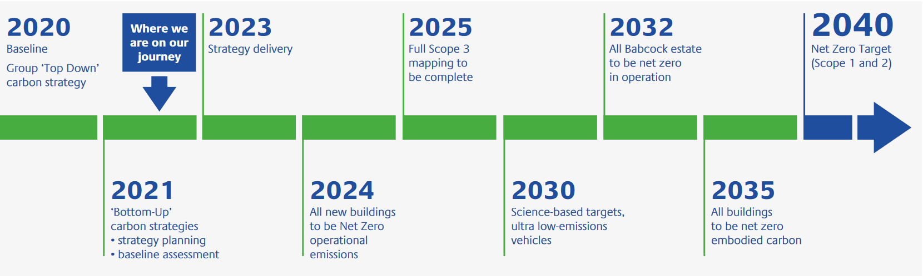
2. *Babcock International Group PLC’s Scope 1 and 2 Carbon Emissions – Actual vs Projected(Below)*

   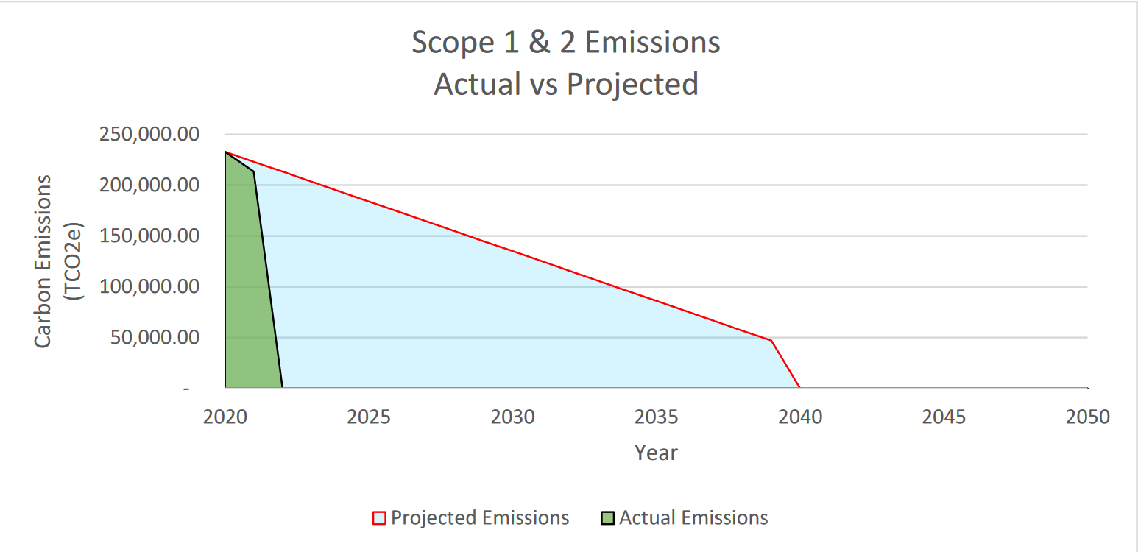
3. *Babcock International Group PLC’s Scope 3 Carbon Emissions – Actual vs Projected(Below)*

   